**Quiz 01**

**Game Development Lab**



**Fall 2024**

Name : **AWAIS SADDIQUI**

Reg # : **21PWCSE 1993**

Section: **“A”**

Submitted To:

**Abdullah Hamid Sir**

**Computer Systems Engineering, University of Engineering and Technology Peshawar.**

**Question: 01**  
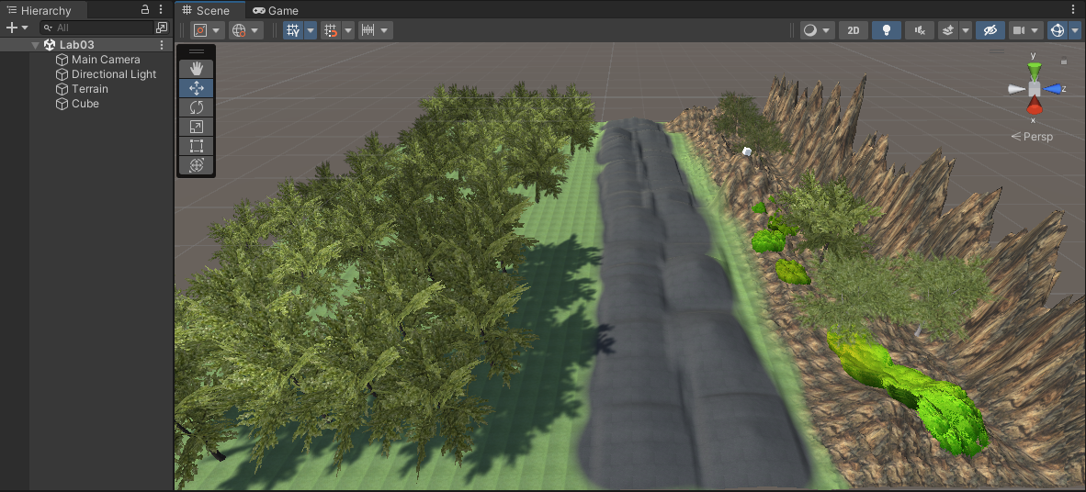

**Checked on Laptop**